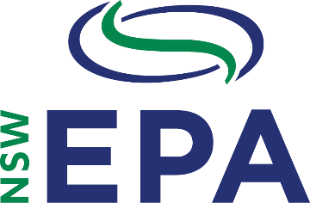
www.epa.nsw.gov.au
Waste Less, Recycle More Initiative
Product Improvement Program: Round 2
Project Plan Template

Part C: Project Plan
The project plan shows how you intend to implement the project described in the application. Please use this form to complete your project plan. Please refer to the ‘Project Plan definitions’ to help you complete this form.
Organisation name
The project plan is designed to demonstrate the applicant’s ability to deliver the project on time and to a high standard.
Please complete Part C and submit it with your application form.

Does your organisation have formal management systems for quality, environmental management and/or work health and safety?
Note: This form is not locked and will expand with supplied detail.
Item | Detail
Title
Objective
Output(s)
Outcomes
How the success of the project will be measured (monitoring and evaluation)
Governance
Resources
Stakeholders
Major risks and minimisation strategies *If you are attaching a separate Risks and Mitigation Strategy this may be left blank
Related projects
Quality control
Procurement strategy
Tasks: key project steps
Technical standards and legislative requirements
Capturing the lessons learnt

EPA 2019P1648
June 2019

