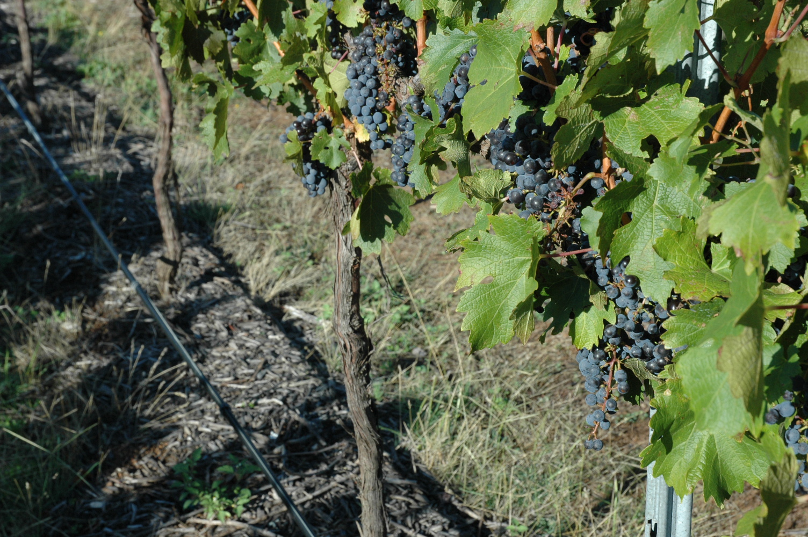

Organics Market

Development Grants
  - Round 3

  - Application Form
  - Applications close 4pm, Thursday 22 November 2018

www.epa.nsw.gov.au

www.epa.nsw.gov.au
© 2018 State of NSW and the NSW Environment Protection Authority
With the exception of photographs, the State of NSW and the NSW Environment Protection (EPA) Authority are pleased to allow this material to be reproduced in whole or in part for educational and non-commercial use, provided the meaning is unchanged and its source, publisher and authorship are acknowledged. Specific permission is required for the reproduction of photographs.
All content in this publication is owned by the EPA and is protected by Crown Copyright, unless credited otherwise. It is licensed under the Creative Commons Attribution 4.0 International (CC BY 4.0), subject to the exemptions contained in the licence. The legal code for the licence is available at Creative Commons.
The EPA asserts the right to be attributed as author of the original material in the following manner: © State of New South Wales and the NSW Environment Protection Authority 2018.

Cover photo: ‘Mulched Merlot’ by Annie Kavanagh

Published by:
NSW Environment Protection Authority
59 Goulburn Street, Sydney NSW 2000
PO Box A290, Sydney South NSW 1232
Phone: +61 2 9995 5000 (switchboard)
Phone: 131 555 (NSW only – environment information and publications requests)
Fax: +61 2 9995 5999
TTY users: phone 133 677, then ask for 131 555
Speak and listen users: phone 1300 555 727, then ask for 131 555
Email: info@epa.nsw.gov.au
Website: www.epa.nsw.gov.au

www.epa.nsw.gov.au

Report pollution and environmental incidents
Environment Line: 131 555 (NSW only) or info@epa.nsw.gov.au
See also www.epa.nsw.gov.au
EPA 2018P1171
September 2018

Applying for a Round 3 Organics Market Development grant - 2018
  - Read The Guidelines for applicants document which can be downloaded from the EPA website - Application Guidelines – Organics Market Development grants Round 3.
  - Complete this Application form.
  - Complete the Budget form (Excel document, available for download from the EPA website.
  - Attach any supporting documents (these should not be bigger than 10MB in total).
  - Submit your application no later than 4pm, Thursday 22 November 2018 by emailing organics.grants@epa.nsw.gov.au with the subject line: ‘Your organisation name: Round 3 Organics Market Development Grants Program Application’.

Application form
- Before starting, read the Application guidelines to ensure you are eligible. Note that Organics Market Development grant funding is offered to organisations, not individuals.
- Answer all questions in the Application form. Incomplete or ineligible applications will not be considered.
All documents must be submitted by 4pm, Thursday 22 November, 2018 by:
- emailing: organics.grants@epa.nsw.gov.au with the subject line: ‘Your organisation name: Round 2 Organics Market Development Grant Application’.
If you have any questions, please contact the NSW EPA Organics Unit by emailing organics.grants@epa.nsw.gov.au or phoning (02) 9995 6874 or (02) 9995 6895.

Application details
Please complete the following details. Make sure that at least one of the contact people listed below will be available throughout the entire grant delivery period.

Lead organisation
Name of organisation
ABN
Postal address
Street address
Suburb
Postcode
Local government area
State electorate
Website address
Registered for GST?

Project manager (primary contact)
Title
Name
Organisation
Email
Phone
Role in project

Secondary contact
Title
Name
Organisation
Email
Phone
Role in project

Administrator (if different from above)
Name of organisation
ABN
Postal address
Street address
Suburb
Postcode
Local government area
State electorate
Website address
Registered for GST?
Contact person
Phone
Email
Involvement in project
Have you and the grant applicant signed a memorandum of understanding?

Project details
Please use a maximum of 100-word summary. State briefly how the project will align with the program objectives. This summary may be used in web postings and other official grant communication media.

Project Title
Project Summary

Funding amount requested
How much funding are you requesting? Grants between $20,000 and $200,000 (excluding GST) are available.

Amount requested | $

Insurance
It is a condition of your grant that you have insurance cover, including public liability insurance of $10 million, workers’ compensation and volunteer insurance if applicable. Please provide details of your insurance below.

Insurance details
Public liability
Insurance company
Policy number
Coverage
Currency (expiry date)
Workers compensation
Insurance company
Policy number
Coverage
Currency (expiry date)
Volunteers or PI (if needed)
Insurance company
Policy number
Coverage
Policy number

Assessment criteria
The assessment process for the Organics Market Development grants is a state-wide, merit-based contestable process. Eligible applications are assessed by a Technical Review Committee (TRC) against the assessment criteria.
State clearly the ways in which your project will meet each of the three assessment criteria. Refer to the Application guidelines for advice on addressing the assessment criteria. All questions in the Application form should be answered fully, clearly and succinctly.

1. Project preparation – (35% of the assessment score) | Questions 1 - 6
2. Capacity to deliver – (35% of the assessment score) | Questions 7 - 11
3. Value for money – (30% of the assessment score) | Questions 12 – 15 and Budget form

Criterion 1: Project preparation
  - Describe your project in detail (no word limit) explaining what the project involves, what you expect to achieve and who you will be working with. Which locations will your project cover? Include a description of how the idea for the project was developed and the work done to date to develop the project idea and project plan.

  - Briefly explain how your project will support the aim and objectives of the Organics Market Development Program to help the expansion of the NSW markets for source separated recycled organics products by an extra 70,000 tonnes by:
    - increasing knowledge and awareness
    - supporting the improvement in the quality of products produced
    - supporting the development of new and innovative market niches.

  - Performance objectives. In the table below outline the objectives, targets and key performance indicators (KPIs) for your project.
The number of targets and KPIs will depend on the complexity of your project.
Consider how you will collect the data on targets and KPIs. If your application is successful, you will need to report back to the EPA on these targets and KPIs.

Overall objective | Targets | KPIs

  - What is your target market?

  - What do you know about your target audience or their current compost awareness and use?
How will you measure their awareness and behaviour? How will you measure the effect of your project on their behaviour change? Please be as specific as possible.

  - Communications. How will you communicate your project’s activities and outcomes to the extended market, the NSW organics processing industry and the broader community?

All projects are expected to have a strong communication and outreach component. Provide a clear overview of the proposed communication activities, the rationale for the chosen communication channels and how you will measure success. The preparation of a detailed communication plan can be included as an activity within your project.

Criterion 2: Capacity to deliver
  - Project management. Detail how your organisation will manage the project.
What processes will you put in place to meet timelines, deliver on milestones, monitor progress and keep the project on track? Detail the roles of partners. If you intend to use sub-contractors, explain the roles of the sub-contractors and how they will be managed.

  - Capacity to deliver. Describe the capacity of your organisation to carry out all aspects of the project successfully. What skills/experience do you have? Include a brief outline of your organisational structure and the expertise which will support the delivery of your project. If you are employing new staff for this project, please detail here.

  - Regulations. Detail how you will ensure that recycled organics used in your projects are made from source separated material of suitable quality and fit-for-purpose. Include how you will ensure these products satisfy the EPA’s Resource Recovery Exemptions and Resource Recovery Orders.

  - Risk Management. Explain the risks that might impact on your project delivery and how you will manage them.

Risk description  Must show an understanding of the context of the risk, as well as its likely cause and possible consequences | Risk level  High (H), Medium (M), Low (L) | Prevention strategy  To reduce the risk or solve any problems as they occur

  - Agreement to attend monthly meetings with EPA
Successful applicants will need to have a monthly phone or face-to-face update meeting with the EPA Organics Unit.
Please confirm your commitment to monthly update meetings by ticking the box below.
☐ I agree to attend monthly meetings with the EPA regarding project progress.

Criterion 3. Value for money
  - How much funding are you seeking from the EPA?
Grants of between $20,000 and $200,000 are available. For more details see Guidelines for applicants.

Years | Funds ex GST
2018-2019 | $
2019-2020 | $
2020-2021 | $
TOTAL | $

  - Budget. Provide a detailed project budget as ‘Attachment B’ to this application, using the Excel Budget form provided.

Summarise the key activities budget here (i.e. a list of the total project unit costs and the funding you are seeking for each from the EPA). Include details of all complementary resourcing (cash or in-kind); this adds value for money for your project.

Project Item | EPA Contribution ($) | In-kind ($ equivalent)

  - Funding from other sources. List any other grants that you (the applicant, partners and sub-contractors listed in this application) have/will receive relating to the activities proposed in this project.

Note: Work that would have been undertaken as part of agreed commitments or existing programs or business activities is not eligible for funding.
Funding/payment source | Agency providing the funding/ payment | Amount of funding/payment | Relationship to this project

  - How will you leverage, measure and communicate ongoing benefits for your project after the funding has been completed?

Approval authorisation
Please provide the name of one senior office-bearer in your organisation (e.g. Director, Chairperson, Treasurer, Chief Executive Officer or Executive Officer) who can confirm the accuracy of the information in the application.
Name
Title/position
Organisation
Email
Phone
Date
Signature

Submit this form as a Word document by 4pm November 22, 2018 to organics.grants@epa.nsw.gov.au with the subject line: ‘Your organisation name: Round 3 Organics Market Development Grant Application’.

