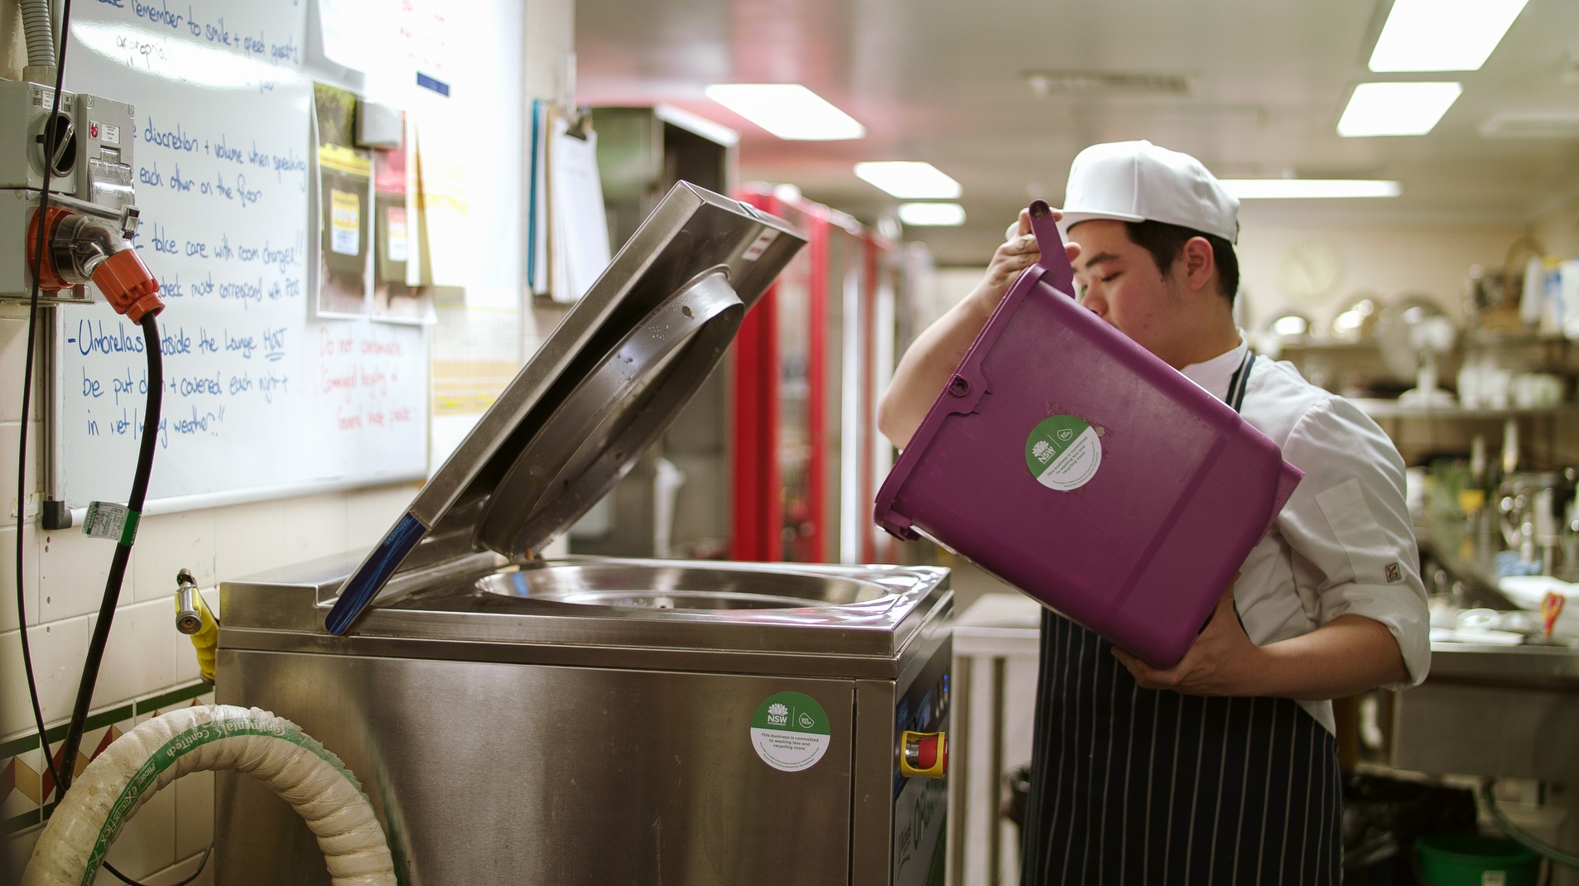
Bin Trim Program Round 4
Application Form
Waste Less, Recycle More
Business Recycling Fund

Published by NSW Department of Planning, Industry and Environment
dpie.nsw.gov.au
Title: Bin Trim Program Round 4
Subtitle: Application Form
First published: December 2019
DPIE 2019P2044
Cover image: Food waste being processed for recycling at Lilianfels Resort, Blue Mountains. Photo: Republic of Everyone.
© State of New South Wales through Department of Planning, Industry and Environment 2019. You may copy, distribute, display, download and otherwise freely deal with this publication for any purpose, provided that you attribute the Department of Planning, Industry and Environment as the owner. However, you must obtain permission if you wish to charge others for access to the publication (other than at cost); include the publication in advertising or a product for sale; modify the publication; or republish the publication on a website. You may freely link to the publication on a departmental website.
Disclaimer: The information contained in this publication is based on knowledge and understanding at the time of writing (October 2019) and may not be accurate, current or complete. The State of New South Wales (including the NSW Department of Planning, Industry and Environment), the author and the publisher take no responsibility, and will accept no liability, for the accuracy, currency, reliability or correctness of any information included in the document (including material provided by third parties). Readers should make their own inquiries and rely on their own advice when making decisions related to material contained in this publication.

Contents
Information for applicants 1
Checklist 1
A. Lead organisation details 2
A.1 Lead organisation type 2
A.2 Lead applicant details 2
A.3 Name of any partner organisation/s and subcontractors 2
A.4 Insurance 3
Public liability insurance ($10M) 3
Workers compensation insurance/personal accident insurance 3
A.5 Compliance with NSW environment protection laws 3
B. Personnel 4
B.1 Project manager contact details 4
B.2 Organisation description 4
B.3 Personnel – qualifications, skills and experience 4
C. Project proposal 5
C.1 Project timeframe 5
C.2 Project budget 5
C.3 Project summary and rationale 5
C.4 Project outputs 6
C.5 Project outcomes 7
C.6 Integration with other services or activities 7
C.7 Other participants 7
C.8 Recruitment 7
C.9 Waste assessments - methodology 8
C.10 Action plans and implementation support 8
C.11 Administration, monitoring and reporting of outcomes 8
C.12. Bin Trim equipment rebate 8
D. Project management 9
D.1 Project plan 9
D.2 Risk management plan 10
E. Financial information 11
E.1 Project expenditure summary 11
E.2 Resources from other sources 12
F. Certification 12

Information for applicants
Please read the Bin Trim Round 4 Information for Applicants document before starting your application.
Answer every question. This will help provide an overall picture of your project to the Technical Review Committee. If a question is not relevant write ‘n/a’. Consult with the Department of Planning, Industry and Environment’s Bin Trim team if you have any questions about the eligibility of your proposal.

Checklist
Before submitting your application:
☐ Complete the summary table below
☐ Attach a copy of the lead organisation’s insurance Certificate of Currency.
☐ Include the signature of an office bearer from your organisation and other organisations you propose to work with (see Section F for details).
Table 1: Application summary table
Application summary table
Date submitted
Lead organisation
Main contact – contact details
Project title
Funding amount sought
No. of businesses to complete Bin Trim process
Total no. of tonnes to be diverted from landfill
Reduction in waste generation (tonnes)
No. of tonnes to be recycled
To be completed by DPIE
Date received
For assistance or enquiries, email bin.trim@epa.nsw.gov.au or phone Lesley Fox
on (02) 9995 5516.
Please do not attach general company information such as brochures and pamphlets.
Submit your completed application and all attachments to bin.trim@epa.nsw.gov.au by Friday, 28 February 2020.
Late or incomplete applications will not be accepted.

A. Lead organisation details

A.1 Lead organisation type
The lead organisation must be a legal entity. Please select all that apply:
☐ Waste and/or recycling service provider
☐ Recycling infrastructure/equipment supplier
☐ Waste and/or recycling consultancy
☐ Local council
☐ Group of councils
☐ Company
☐ Sole trader
☐ Partnership
☐ Non-government/not-for-profit organisation
☐ Other (specify)

A.2 Lead applicant details
Organisation
Registered for GST (Y/N) |  | ABN
Address
Suburb |  |  |  | State |  | Postcode

ACN (if a company)

State of registration

A.3 Name of any partner organisation/s and subcontractors
Organisation
Registered for GST (Y/N) |  | ABN
Address
Suburb |  |  |  | State |  | Postcode
Organisation
Registered for GST (Y/N) |  | ABN
Address
Suburb |  |  |  | State |  | Postcode

A.4 Insurance
Attach copies of Certificate of Currency to emailed application.

Public liability insurance ($10M)
Name of insurance company
Policy numbers
Coverage
Currency (Expiry date)

Workers compensation insurance/personal accident insurance
This table is for sole traders only.
Name of insurance company
Policy numbers
Coverage
Currency (Expiry date)
Include the same details for each proposed subcontractor.

A.5 Compliance with NSW environment protection laws
Complete for the lead applicant and any partners or subcontractors that are facility operators.
What Environment Protection Authority Licence/s do you currently hold for your facilities?
In the last five years have you or any partner organisations received any penalty notices, clean-up notices, prevention notices, license suspensions, licence revocations, conviction or prosecutions under NSW environment protection laws including National Parks and Wildlife Act 1974, Protection of the Environment Operations Act 2014 (POEO Act) and the Native Vegetation Act 2003?
☐ Yes
☐ No
If you answered yes to the above, please provide details, including any improved processes implemented to correct these breaches (attach additional supporting information to your emailed application if needed).

Since 1 July 2017, have you contravened any provision of the POEO Act with the result of avoiding, minimising or undermining the requirement to pay any waste contributions required under section 88 of the Act? See the Information for Applicants for more information on relevant sections of the Act and the Protection of the Environment Operations (Waste) Regulation.
☐ Yes ☐ No
If you have answered Yes to the above, please answer all questions below:
The date(s) of the contraventions
The sections or clauses contravened
The person or person(s), including the full names of any relevant directors or managers, who contravened the sections or clauses
The nature of the contravention
The waste activities being undertaken at the time of the contravention
The amount in tonnes and types of waste (including by waste classification) involved
Steps taken to rectify the situation
If you have answered yes to the above, your organisation may not be eligible for funding.

B. Personnel

B.1 Project manager contact details
Provide details of the main contact person for the project in the organisation. Please nominate two contacts. At least one nominated contact must be available and authorised to negotiate during business hours at all times during the assessment period (March/April2020) if required.
Primary contact |  | Alternative contact
Name: |  | Name:
Title: |  | Title:
Phone: |  | Phone:
Mobile (required): |  | Mobile (required):
Email: |  | Email:

B.2 Organisation description
Provide a brief description of your organisation, and any partner organisations, including previous project management experience, areas of relevant expertise, experience in conducting waste assessments and working with businesses to reduce their waste generation and increase recycling.

B.3 Personnel – qualifications, skills and experience
List the persons to be employed (including partners and subcontractors) on the various components of the project, identifying each person’s proposed role and the extent of their involvement. Provide the other details as specified. Please only name staff who will actually be working on the project. Please do not provide full CVs in this document or as an attachment – a summary of relevant skills and experience is all that is required. If you need extra space, feel free to provide the information in an Excel spreadsheet instead.
Name | Organisation | Title | Role and responsibility within the project | Qualifications and relevant experience | Expected timing and duration of involvement in the project
Principals
Personnel
Personnel
Personnel
Personnel
Personnel
Personnel
Will any new employees be recruited for this project?
If yes, how many do you estimate will be recruited?

C. Project proposal

C.1 Project timeframe
Projects can start no earlier than May 2020 and must finish no later than May 2021.

C.2 Project budget
Nominate the amount of funding sought from a minimum $50,000 to a maximum $300,000 (ex GST). The amount must be the same as the figures in E1. Project expenditure summary.
Amount sought: $
Your cash and in-kind contribution: $
Total project budget: $

C.3 Project summary and rationale
Provide a brief summary of your project (maximum of 100 words).
This should provide an overview of what your project will do and what it will achieve. Include information about the number of businesses and industry sector to be targeted, the geographic area/s to be covered, and the overall approach you will take.
Information from this summary may be used to promote your project/s online and in other public promotion opportunities.

C.4 Project outputs
Sector | Target materials for recycling | Number of businesses | Small business  (1-19 employees) | Medium business  (20-200 employees) | Large business (200+ employees) | Estimated diversion of waste from landfill (tonnes/annum) | Estimated reduction in waste generation (tonnes/annum) | Estimated increase in recycling (tonnes/annum)
Example: offices | Paper/cardboard | 120 | 80 | 20 | 20 | 6,800 T/annum | 4,800 T/annum | 2,000 T/annum
Total

Local government areas (LGAs) to be targeted
(Use list of LGA in Information for Applicants)
Number of small-scale recycling equipment rebate applications to be submitted
Estimated cost savings/revenue to be achieved

C.5 Project outcomes
Provide information about the key materials you will target and the expected total increase in recycling and total reduction in waste generation per annum from all businesses as a result of the grant. Provide same information for small-scale equipment rebates. Explain how these estimates have been made and identify the assumptions made in determining these estimates. Explain the risks and uncertainties around achieving these outcomes.

  - A. Reduction in waste generation (tonnes)
  - B. Increase in recycling (tonnes)
  - C. Number of tonnes to be diverted from landfill (tonnes) (A+B=C)

C.6 Integration with other services or activities
How will your project complement and add value to other services or activities conducted by your organisation, your partners or subcontractors? Will your project produce resources of value to others such as industry benchmarks, guides, or educational materials? Will this experience create an ongoing capability or legacy within the lead applicant’s organisation and if so, how?

C.7 Other participants
Will any other organisations, businesses, networks or groups (other than the named applicants) be involved in conducting the project?
How will these organisations be involved in the project?

C.8 Recruitment
Describe your recruitment strategy, demonstrating your experience in recruiting businesses for similar projects and/or the extent to which you will engage with your current client base.
Identify the areas you propose to target. This may be by geographic region, industry sector and/or existing client base. Identify who will do the recruitment, the process they will use and how many businesses will complete the Bin Trim program (e.g. from registration to first assessment, action plan, implementation, second assessment and action plan).
Please note this should be the number quoted in Table 1: Application Summary Table. To complete the Bin Trim program you will need to target additional businesses to allow for businesses who choose not to participate, do not follow through or are ineligible to contribute to your business target.
Important note: If your organisation is a waste and/or recycling service provider you must only target your existing clients. Engagement must include a face-to-face component and cannot be done remotely.

C.9 Waste assessments - methodology
Describe your assessment strategy, including how many assessments you intend to conduct both first (initial) and second (follow up) assessments. Outline the process and timeframe for these assessments and who will manage this process.

C.10 Action plans and implementation support
Research has shown helping businesses to implement their action plans is key to optimising outcomes. The more time and assistance given, the better the results.
Describe your process for supporting businesses with the implementation of their action plans. Identify who will manage and provide this support. Outline your strategy for encouraging/assisting the adoption of suggested changes, including the purchase of equipment eligible for a rebate. Consider issues that may arise at this stage and actions you will take to avoid, identify, monitor and manage these issues.
Important note: you may only provide quotes to recruited businesses for new or enhanced recycling services from their existing waste/recycling service provider. If the proposed new services are not available from the current service provider/s, three alternative quotes may then be sought.

C.11 Administration, monitoring and reporting of outcomes
Provide an outline of review points, verification methods and internal monitoring/reviews proposed for the project. Identify how the administration and reporting requirements of the project will be met and who will be responsible for project performance.
Note: A progress report, and a final and financial report will be required. Templates will be provided. Outline contingency plan/resources that can be activated if needed to ensure the project remains
on track.

C.12. Bin Trim equipment rebate
A Bin Trim small-scale equipment rebate is available to eligible businesses. Please outline what skills and experience assessors will have in identifying and recommending the need for new waste management equipment, presenting the case for equipment purchase to the business and managing the rebate application process.

D. Project management

D.1 Project plan
Identify your project timeline and major milestones.
Payments will be awarded based on the completion of three project milestones, with the first milestone being the signing of the contract.
Your project must be 50% complete by 20 November 2020 when your progress report is due. Your final report will be due by 14 May 2021. Ensure the project plan clearly shows how you will meet your targets by these dates. If you need extra space, feel free to provide the information in an Excel spreadsheet instead.
Milestone | Milestone and task name | Date completed
Milestone 1 due 17/04/2020 | Contract signed
Task 1.1
Task 1.2
Task 1.3
Task 1.4
Task 1.5
Milestone 2 due 20/11/2020 | 50% of work complete
Task 2.1
Task 2.2
Task 2.3
Task 2.4
Task 2.5
Milestone 3 due 14/05/2021 | Project completion.  Final and financial report to be submitted.
Details on how to calculate the Milestone 2 task 50% complete figure are on Page 11 of the
Information for Applicants.

D.2 Risk management plan
Identify the risks your project could encounter at each milestone and detail the mitigating strategies
you will engage for each one If you need extra space, feel free to provide the information in an Excel spreadsheet instead.
Milestone | Risk factor | How will the risk be monitored and managed?
e.g. milestone 1, recruit 50 businesses | Recruitment target not met | Registrations monitored weekly by the project manager and additional support or resources provided to assessors as required. Additional resources will be applied to the project as necessary. Recruitment contingency plan XXXX to be put in place if registrations are not tracking as planned after one month.

E. Financial information

E.1 Project expenditure summary
List all costs associated with the project in the following budget table.
Factor in assessor time spent recommending, submitting and managing Bin Trim Rebate applications for eligible businesses. No incentive payments will be made in round four as in previous rounds. If you need extra space, feel free to provide the information in an Excel spreadsheet instead.
Note: If you are registered for Goods and Services Tax (GST) the amount requested should not include any amount of GST which may be payable on a listed item. GST paid by entities registered for GST purposes will generally be able to be claimed as Input Tax Credits.
 | Applicant contributions  (applicant, partner, subcontractor or other agency contributions) |  | Grant amount requested from DPIE  (ex GST)  (c) | Project budget (ex GST)  (a + b + c)
 | In kind (a) | Cash (b)
1. Project management and project delivery (specify staff time, auditing, writing reports, administration etc)
e.g. principal @ $X/hr x X hrs
e.g. financial auditor (if required)
Subtotal
2. Travel
Subtotal
3. Education and marketing*
e.g. attending Bin Trim App training
Subtotal
4. Small recycling items (max $1,000 per business)**
e.g. internal recycling bins
Subtotal
Other
Submission and management of rebate applications***
Subtotal
Totals (ex GST)
* Total funding requested for the education and marketing line item can be no more than 10% of the total funding request. Some promotional materials will be provided by the Department of Planning, Industry and Environment (DPIE).
** Total funding requested for the small recycling items line item can be no more than 10% of the total funding request. Receipts and details of businesses to whom the equipment is given must be kept and provided on request and in the Financial Report. Funding is for recycling and waste avoidance equipment only (e.g. does not include general waste bins except where they are provided as part of a suite of bins that includes recycling bins).
*** For each rebate approved over $10,000, a maximum of $750 will be paid. For each rebate approved under $10,000, a maximum of $500 will be paid.

E.2 Resources from other sources
List any other grants or payments you (the applicant, partners and subcontractors listed in this application) have/will receive relating to this project. This includes commissions paid by partners, subcontractors or other parties as well as funds DPIE and other state or commonwealth agencies have/will issue. If you need extra space, feel free to provide the information in an Excel spreadsheet instead.
Note: This grant will fund additional work above existing commitments. It will not fund work that would have been undertaken as part of agreed commitments or existing programs.
No grantee is to receive payment from businesses for any work covered by this grant. If this work leads to further work for which the grantee will receive payment from the business, the grantee must inform DPIE in writing before undertaking the work.
Funding/payment source | Amount of funding/payment | Describe the relationship to this project

F. Certification
The General Manager or an officer at Director level should sign this application.
(If a partnership is applying, the lead applicant must sign this section)
I certify that, to the best of my knowledge, the information in this application is true.
If the NSW Department of Planning, Industry and Environment awards funds to this application, I will accept in full the conditions of the funds on behalf of my organisation.
Name
Signature
Click to upload image
of signature
Position in organisation
Date

