November

Litter-Regional Implementation Program

Background and Supporting Information

 [www.epa.nsw.gov.au](http://www.epa.nsw.gov.au)

RWS

© 2018 State of NSW and the NSW Environment Protection Authority

With the exception of photographs, the State of NSW and the NSW Environment Protection Authority (EPA) are pleased to allow this material to be reproduced in whole or in part for educational and non-commercial use, provided the meaning is unchanged and its source, publisher and authorship are acknowledged. Specific permission is required for the reproduction of photographs.

The EPA has compiled this Litter-Regional Implementation background and supporting information document in good faith, exercising all due care and attention. No representation is made about the accuracy, completeness or suitability of the information in this publication for any particular purpose. The EPA shall not be liable for any damage which may occur to any person or organisation taking action or not on the basis of this publication. Readers should seek appropriate advice when applying the information to their specific needs. This document may be subject to revision without notice and readers should ensure they are using the latest version.

All content in this publication is owned by the EPA and is protected by Crown Copyright, unless credited otherwise. It is licensed under the [Creative Commons Attribution 4.0 International (CC BY 4.0)](http://creativecommons.org/licenses/by/4.0/deed.en), subject to the exemptions contained in the licence. The legal code for the licence is available at [Creative Commons](http://creativecommons.org/licenses/by/4.0/legalcode).

The EPA asserts the right to be attributed as author of the original material in the following manner: © State of New South Wales and the Environment Protection Authority 2018.

Published by:

NSW Environment Protection Authority  
59 Goulburn Street, Sydney NSW 2000  
PO Box A290, Sydney South NSW 1232  
Phone: +61 2 9995 5000 (switchboard)  
Phone: 131 555 (NSW only – environment information and publications requests)  
Fax: +61 2 9995 5999  
TTY users: phone 133 677, then ask for 131 555  
Speak and listen users: phone 1300 555 727, then ask for 131 555  
Email: [info@epa.nsw.gov.au](mailto:info@epa.nsw.gov.au)   
Website: [www.epa.nsw.gov.au](http://www.epa.nsw.gov.au)

**www.epa.nsw.gov.au**

Report pollution and environmental incidents  
Environment Line: 131 555 (NSW only) or [info@epa.nsw.gov.au](mailto:info@epa.nsw.gov.au)  
See also [www.epa.nsw.gov.au](http://www.epa.nsw.gov.au)

ISBN 978 1 922260 14 7  
EPA 2018P1339  
December 2018

Contents

Program background: support document 6

L-RIP background 6

Previously funded L-RIP projects 6

Regional litter plans 6

Review and update of regional litter plan 7

What must a Regional Litter Plan include? 7

Setting up your regional litter working team 8

When should stakeholders be consulted? 8

Identifying partnerships 8

Supporting research 9

Where are we today? 9

Where do we want to be? 10

Strategic objectives and targets 10

Targets 10

Stakeholder engagement 11

How will we get there? 11

The key pillars of effective litter programs 12

Education and awareness 12

Infrastructure 12

Regulation and enforcement 12

Evaluating and monitoring 12

Narrowing down options and assessing performance 12

Costings and funding allocations 13

How success will be measured 13

Monitor 13

Evaluate 13

Appendices 14

Appendix A – State context for tackling litter 14

NSW Litter Strategy 14

NSW commitment to tackle litter 14

How do we measure litter in NSW? 14

Introduction of Return and Earn in NSW 15

How is NSW doing? 15

NSW’s priority sites and materials 17

What we know about litter and litterers 18

What are the financial costs of litter in NSW? 19

Appendix B – Current litter practices 20

Appendix C – Questionnaire 21

Appendix D – Survey to assess service demand and gaps 26

[Appendix E – Case study of completed  
Regional Litter Projects 29](#_Toc531957826)

[Appendix F – Regional litter priorities, objectives  
and targets 30](#_Toc531957827)

Appendix G – Potential project scope 31

Appendix H – Regional litter priority projects 32

Appendix I – Litter location types 34

Own it and Act Framework Overview 36

How do we embed these reductions and lock in the positive impacts? 36

Who needs to ‘own it and act’? 36

What are the enabling factors to help us all ‘own it and act’? 37

Leadership 37

Process 37

Commitment 37

Permission 37

Section 1:

L-RIP Program Background

Program background: support document

This section provides background information on the Litter – Regional Implementation Program (L-RIP) and guidance to support Regional Waste Groups (RWG) update their regional litter plans.

L-RIP background

The NSW Government has set an ambitious litter reduction target through the Premier’s Priority for litter, announced in September 2015. This follows previous NSW Government commitments to reduce litter in NSW by 2021: Between 2012 and 2021 the NSW Government is providing $50 million through the Waste Less, Recycle More initiative to achieve litter reduction goals.

In 2013–14, regional organisations of councils (ROCs) and voluntary Regional Waste Groups (RWGs) developed and delivered regional waste strategies that define waste-related priorities for their region. These include identified objectives and targets to reduce litter.

In 2015, the EPA developed the L-RIP to help RWGs develop regional litter plans. In 2016-17 and 2017-18 it jointly (with councils) funded the delivery of litter implementation plans.

Regional collaboration continues to be critical. This is not only for delivering the priorities of the regional waste strategies but also for delivering the NSW Government’s Waste Less, Recycle More initiative and the Premier’s Priority on litter reduction.

Previously funded L-RIP projects

In 2016, the 15 RWGs were funded a total of $1.2 million to implement priority projects identified in their litter implementation plan.

In 2017, $170,000 was made available from the L-RIP Enhancement grant round to five RWGs.

In 2017-18, $1.18 million was awarded to RWGs to deliver 14 regional litter projects.

More detail on previous litter grants can be found here: <https://www.epa.nsw.gov.au/working-together/grants/litter-program/council-litter-grants>

Regional litter plans

This section includes guidance on how to review and update the regional litter plans to ensure that priorities are based on evidence from participating councils and other sources.

Templates are included in the appendices to help support the review process. Where new evidence has become available, this will be used to review regional litter priorities and projects. These templates may only be required when a substantial review is being undertaken.

The Regional Litter Plan should remain an easy-to-read document which highlights priorities and strategies to meet identified targets. It needs to easily inform internal and external stakeholders about current litter challenges in the region, what it wants to achieve and why and set out what measures will be put in place.

It should be written as a public-facing document. It may be referenced by councillors, council executive, council staff and the public. The tone, language and style needs to be simple, straightforward and easy to follow.

Review and update of regional litter plan

While it is assumed that the three-to-five-year regional litter plans developed in 2015 are still current, it is acknowledged there might be a need to review and refine them based on:

* experience and knowledge gained from Stage 2 and 3 regional litter project implementations
* regional waste strategy engagement process
* the growing knowledge and ownership of litter issues of member councils
* amalgamation of councils and the subsequent effect on RWG membership.

If an RWG intends to make significant changes to the current litter prevention targets and objectives when updating a regional litter plan, it must obtain approval from the EPA.

The 12-month Litter Implementation Plan must be updated and submitted to the EPA with their Regional Litter Plan if an RWG wishes to apply for Stage 4 L-RIP grant funding.

Templates and guidance are available form the Litter Prevention Unit if required.

## **What must a Regional Litter Plan include?**

The Regional Litter Plan must include several elements.

1. **Introduction**  
   A short summary covering the background of the councils in the regional grouping, the policy context, the connection with the Regional Waste Strategy and how the Regional Litter Plan has been developed and evolved.
2. **Where are we today?**Outline the evidence on regional litter challenges and litter prevention activity being undertaken. This will enable the RWG to review and refine current high-level demand and gap analysis. This evidence will also inform decisions regarding target-setting, areas for intervention, action and investment.
   1. Start with the current NSW context for tackling litter. This is provided by the EPA and is at Appendix A.
   2. Outline the regional context for litter reduction. This can repeat relevant information from the Regional Waste Strategy, including litter objectives and targets.
   3. Identify any changes to member council litter policies and strategies (where they exist).
   4. Collect and update data on the current litter practices across the region against each of the four pillars for litter reduction: education and awareness, infrastructure, regulation and enforcement and evaluation and monitoring.
   5. Review and update the regional stakeholder map and work with these stakeholders to update data on current service demands and/or gaps. For example: locations where litter bins are overflowing or need additional emptying, or which areas regularly need additional clean-up.
   6. Review local litter programs and initiatives.
   7. Outline successes and achievements from L-RIP funded projects.
3. **Where do we want to be?**  
   Review the regional priorities, strategic objectives, regional targets and timelines to drive the plan forward.
4. **How will we get there?**  
   Review the identified options for achieving the objectives. Consider lessons learned and resources available to review and refine the order of priority for existing projects. Where necessary, re-prioritise projects for implementation.
5. **How success will be measured**  
   A successful Regional Litter Plan is one where the objectives for the region are met within the timeframes identified. It is therefore essential to detail what information has been collected and when future progress will be measured against objectives and targets.
6. **Case Studies**  
   Provide a case study of each regional litter project that has been delivered. This will share the achievements as well as lessons learned.

Setting up your regional litter working team

A key component of a high quality Regional Litter Plan and Litter Implementation Plan is engagement with a regional litter team to assist in driving and supporting the review and planning processes. In an ideal world, key stakeholders from each member council should be actively involved in the process. If member councils cannot attend or actively participate, consider how and when they should be consulted on the process to ensure your plan has support. Working in isolation from member councils is not considered best practice.

When should stakeholders be consulted?

If a Regional Litter Plan is to be significantly changed, it is essential to identify internal and external stakeholders at the start of the review process. Consult them to collect data on current and future litter challenges and priorities.

For the Litter Implementation Plan, it is essential to consult with stakeholders who will be nominated for roles and responsibilities in any nominated project(s).

## **Identifying partnerships**

Collaborative arrangements with community organisations, industry and member councils are strongly encouraged. Regions that understand and build good stakeholder networks will achieve longer-lasting litter outcomes and maximise the entire community’s efforts.

There are many completed regional litter projects that were funded through the EPA’s Council Litter Prevention Grants and Community Litter Grants. The EPA can provide information to RWGs about Council Litter Prevention Grants and Community Litter Grants completed or underway in their regions.

There may also be great work being undertaken in regions quite separate to EPA-funded projects and it is important to connect with and understand this work. This will minimise the potential for duplication of effort, and maximise value-for-money projects that can be delivered on the ground.

There have been many litter projects implemented over the years, and the knowledge that has been gained is substantial. Stakeholders are highly valuable sources of information, resources and passion, all of which will be needed in the implementation of the L-RIP Plans.

It is essential to consult with any partners who will be nominated for roles and responsibilities identified in either the Regional Litter Plan or Litter Implementation Plan.

If a litter hotspot is identified on land that is not owned or managed by council, it will be essential to identify the landowner and work in partnership with them during the project planning phase.

Supporting research

The statewide context for litter reduction is provided in Appendix A. The EPA may be able to provide further information by region, if it exists.

In addition, many RWGs have conducted further research on litter prevention over the past few years. This should be referenced in the Regional Litter Plan.

Where are we today?

This section provides the regional profile of the type of litter (e.g. takeaway food containers), type of site (e.g. retail strips) and target litterer (e.g. local workers) for regional intervention and activity.

If the plan is to be reviewed and updated, the baseline regional litter profile documented in the initial Plan should be referenced. Specifically, this should include what progress has been made. Where additional evidence has been collected, the regional litter profile might need refinement.

The regional litter profile provides the evidence base to inform decision-making on priority projects for investment of resources.

Review the currency and relevance of the information used to inform the ‘Where are we today?’ section of your plan.

Update as necessary and ensure this section continues to include:

* a high-level summary of the region’s demographics – as outlined in the Regional Waste Strategy
* an outline of the policy and activity of member councils in terms of the four pillars of litter prevention and reduction. See Appendix B for a template to gather updated information from councils on their current practices.
* member councils’ current costs for managing litter, including clean-up, maintenance, prevention and reduction. See Appendix C for a template questionnaire. This can then be aggregated by region.
* the types and volume of litter being collected by councils, if any
* the identification of litter hot spots by the type of location and type of litter.
  + The survey at Appendix D can be used by councils to survey all relevant staff such as parks and gardens staff, enforcement officers, waste educators, place managers etc.
  + Other sources of data include complaints registered about litter, Clean Up Australia Day sites information, and specific areas where bins are overflowing or where high levels of servicing are required.
* identification of ongoing or new gaps in services or council priorities that are resulting in increased litter. The survey at Appendix D will help you find gaps.
* review of council litter programs, initiatives and their lessons and outcomes
* review of regional litter projects and their lessons and outcomes
* statement of community expectations.

To assist in the collection of data across regions, the EPA will provide the following:

* a summary of National Litter Index data for NSW (Appendix A). We will also provide the full report for additional information.
* the cost of litter to councils. The EPA has collected litter costs from 19 councils across NSW.
* Local Partner Survey template
* Local Litter Awareness Survey template.

Where do we want to be?

Regional Waste Strategies (RWS) set the vision, themes, strategic objectives and targets for future investment and action on waste. One RWS theme centres on combating littering and has driven the development of a three-to-five-year Regional Litter Plan.

Strategic objectives and targets

If you plan to update the objectives of your Regional Litter Plan, remember they must be SMART(described following). An example is provided in section 5.2.

The number of objectives and level of detail will depend on the regional litter profile and how prescriptive councils wish to be.

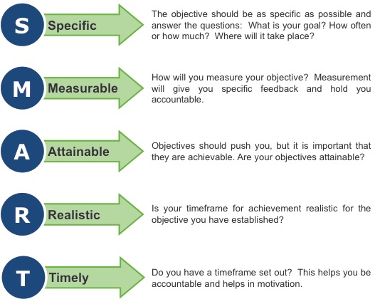

Targets

If objectives are refined, the targets must also be refined.

Targets are deliverables within set timeframes that aim to achieve the objectives through planned actions. Each objective will have at least one target; it may include a series of incremental targets to drive progress towards the objective.

Targets also help identify the KPIs that will measure progress and success. Always consider how to measure success in achieving the target (for example, audits, data collection, community surveys) and confirming that it is measurable and cost effective.

Targets should continue to take into consideration the NSW Premier’s Priority to reduce litter volume by 40% by 2020.

The template at Appendix F can be used to update objectives and targets.

Diagram showing an example of an objective

Stakeholder engagement

Consulting key council stakeholders and political leaders is recommended during the process of reviewing and refining strategic litter objectives and targets.

As recommended previously, RWGs should work with their regional litter team to review the Regional Litter Plan and Litter Implementation Plan. This team should also test and refine the strategic objectives as a key part of their task.

Other key stakeholders may add to the process, for example other land managers such as Roads and Maritime or National Parks staff and community organisation leaders.

How will we get there?

If the strategic objectives have been reviewed and refined, it is important to review existing projects for alignment. Lessons learned and success achieved through implementation of regional litter projects so far should also be considered at this stage.

If there is alignment, review the prioritisation of documented projects. Use the template at Appendix H to record the final prioritised selection.

If there are new objectives and targets, you might need to consider different methods of achieving them. The template at Appendix G may help to guide the development of potential project(s). Review all identified projects together with any new ones and complete an options appraisal to prioritise projects for implementation over the period of your Regional Litter Plan.

It will be essential to prioritise projects for the Litter Implementation Plan.

The key pillars of effective litter programs

The elements of effective litter action are now well established through research. The four key elements are described below. RWGs will need to ensure all project options for litter prevention are based around these elements, remembering that all four elements will be needed to make lasting change.

Diagram showing four integrated behaviour change strategies

Education and awareness

Community education is critical for changing behaviour. It raises awareness and builds the idea that littering is not the right thing to do.

Infrastructure

Clean, well-maintained bins are critical. Infrastructure should take into account who uses the site and how. Together with good ‘binfrastructure’, sites need to be kept clean to reduce litter as this sends the message that litter doesn’t belong.

Regulation and enforcement

Enforcing litter offences is part of strengthening the desired social norm that litter is wrong and that it gets noticed.

Evaluating and monitoring

Anyone tackling litter needs to know what works and why, and what doesn’t work.

Narrowing down options and assessing performance

Where new projects have been developed, it may be necessary to narrow down project options. Review all existing and new projects and complete a high-level assessment of each project’s ability to meet the strategic litter objectives and targets.

Prioritise all projects and define the anticipated timeframe for implementation. This might be the stage where some projects do not make the short-list for implementation within the Regional Litter Plan.

Use the template at Appendix H to record the final selection.

Costings and funding allocations

Assign indicative costings for the prioritised projects. Initially, costs can be based on best estimates. These can be reviewed later and updated when more detailed costing research is carried out or the region calls for quotations or expressions of interest.

How success will be measured

A successful Regional Litter Plan is one where the objectives for the region are met within the timeframes identified. The key is ensuring the objectives and targets are achievable and there is clear ownership of the actions to be completed. Where implementation hinges on funding availability, ensure this is considered and documented in the Litter Implementation Plan action plan template as a ‘project dependency’

Monitor

Monitoring is about collecting data and information, so progress against the objectives and targets can be measured and issues can be identified early and addressed.

The Regional Litter Plan must identify the person(s) responsible for monitoring progress.

Evaluate

It is important that any information gathered is analysed and interpreted. Evaluation will also identify areas for improvement. It is important to review progress against specific actions – have they been completed in the specified timeframe? If not, is there a knock-on effect for other elements of the plan?

When reviewing the Regional Litter Plan, identify the projects that have been implemented. Detail whether they met the intended objectives and targets. These should remain in the document. Use the template at Appendix E.

The Regional Litter Plan must identify the person(s) responsible for evaluation.

The EPA has developed evaluation tools that can help councils measure the impact of their projects. They are:

* The [Local Litter Check](http://www.epa.nsw.gov.au/litter)
* Local Partner Survey template – to be provided to RWGs by the EPA
* Local Litter Awareness Survey template – to be provided to RWGs by the EPA

Appendices

Appendix A – State context for tackling litter

The following information can be used to outline the NSW context for tackling litter, required in the ‘Where are we today’ section of the Regional Litter Plan.

NSW Litter Strategy

This [NSW Litter Prevention Strategy (Consultation draft)](http://www.epa.nsw.gov.au/wastestrategy/litterstrategy.htm) is a first for NSW. It is one of a set of strategies under the *Waste Less Recycle More* initiative and was developed by the EPA. The Strategy will be released in late 2018.

NSW commitment to tackle litter

The NSW Government is serious about reducing litter. Littering harms ecosystems and our natural environment, makes our community look unkempt, and is linked to other anti-social behavior like graffiti.

The NSW Premier has a priority state target **to reduce the volume of litter by 40% by 2020** (see [Premier's Priorities](http://www.nsw.gov.au/making-it-happen)). This builds on the foundation created through the previous focus on reducing the number of littered items in NSW.

To achieve this ambitious goal, the NSW Government has committed $50 million to anti-littering efforts to 2021 as part of the nine year $802 million *Waste Less, Recycle More* initiative.

How do we measure litter in NSW?

To better understand the problem of litter in NSW, we draw yearly data from a variety of sources. According to Keep Australia Beautiful’s National Litter Index, our State has been reducing litter since the Index began in 2005–06.

The data we have is not perfect, but it gives a useful starting point to target our actions and guide priorities.

The [National Litter Index](http://kab.org.au/litter-research/national-litter-index-2) is a broad survey that measures litter by the number and volume of littered items across almost 1000 sites nationally (151 in New South Wales).

The Index only measures land-based litter, not waterways or marine litter. However, the CSIRO completed an Australia-wide survey of marine debris, which included surveying coastal areas for litter. Fact sheets and more information are available on the [CSIRO website](http://www.csiro.au/en/Research/OandA/Areas/Marine-resources-and-industries/Marine-debris).

We also measure litter in local ‘hotspots’ through the EPA’s Local Litter Check. This is a ‘citizen-science’ method that targets local litter problem areas. It helps councils, community groups and others to understand, measure and tackle litter in those hotspots. We continue to collect data from Local Litter Checks to measure the success of local action and build a more complete picture.

The Local Litter Check is now available on line at: <https://litterchecks.epa.nsw.gov.au/LocalLitterChecks/s/login/>.

Introduction of Return and Earn in NSW

The Return and Earn scheme started on 1 December 2017. Over 800 million containers have now been redeemed through over 650 collection points. The scheme is gaining momentum. Return and Earn targets the largest contributor to NSW litter volume – eligible drink containers.

You can find ou more about the scheme at - <https://returnandearn.org.au/>.

How is NSW doing?

NSW has been reducing litter since the National Litter Index began in 2005–06, at around the same rate as national trends.

In the period 2013-14 to 2017-18, NSW litter volume has reduced by 37% (7.0 L per 1000m2 to 4.5 L per 1000m2).

Littered items in NSW have reduced by 27% from 2013-14 to 2017-18 (56 items per 1000m2 to 41 items per 1000m2).

In 2017-18 the volume of litter in NSW covered under Return and Earn reduced by 30% from the previous year.

For the same period, the number of littered items covered under Return and Earn reduced by 24%.

Figure 1: Litter volume per 1000 m2 – NSW and national comparison (excluding illegal dumping)

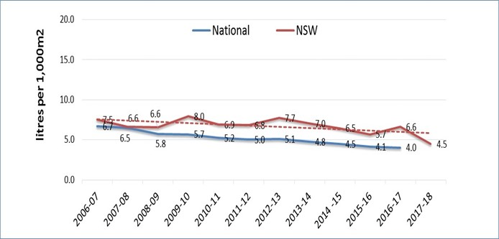

Figure 2: Litter items per 1000 m2 – NSW and national comparison (excluding illegal dumping)

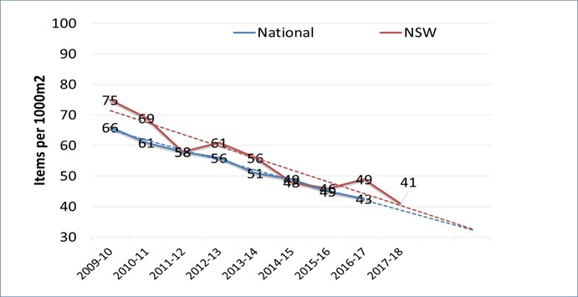

Litter data is inherently variable from year to year. But while we can’t say for certain, we think that the 2017–18 litter reduction may be partly due to the impact of NSW’s litter prevention program. This includes grant projects run by councils and community groups, the *Tosser!* litter campaign, the introduction of Return and Earn and an increased enforcement of litter laws. This is an encouraging result and our challenge is to keep this momentum going.

Drink containers are the single biggest type of litter item and make up 54% of total litter volume. Takeaway containers of all types (plastic, metal, cardboard, coffee cups etc.) are the next largest litter item by volume, making up 23% of the NSW litter stream.[1]

Cigarette butts continue to be the most common type of litter, making up 41% of all litter items. Around seven billion cigarette butts are estimated to be littered in Australia each year.[2] The next most common litter is paper or paperboard items (such as tickets, drink containers, cups, ice-cream wrappers and boxes), and plastic items (including drink containers, cups and straws).

Figure 3: Total litter volume by category in NSW 2017-18

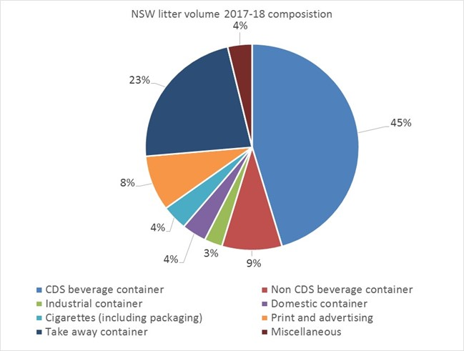

Figure 4: Litter volume by site in NSW 2013–14 to 2017-18

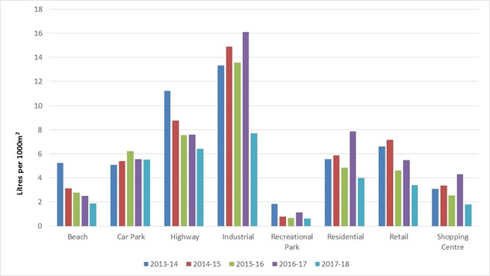

The most littered sites continue to be industrial sites followed by highways and carparks. Recreational parks, shopping centres and beaches are the least littered sites by volume. Some sites, such as transport interchanges, are not measured.

NSW’s priority sites and materials

Based on the National Litter Index, broad NSW priority sites and materials are summarised in the following tables.

|  |  |
| --- | --- |
|  | Priority sites |
| **HIGH** | Industrial areas  Highways and roads  Car parks |
| **MEDIUM** | Retail strips  Transport interchanges  Residential areas |
| **LOW** | Beaches  Shopping centres  Recreational parks  Ovals/sports grounds |

|  | Priority materials |
| --- | --- |
| HIGH | Takeaway containers (all materials – plastic, paper, glass, metal)  Print and advertising  Plastic  Paper and paperboard (e.g. newspapers)  Metal |
| MEDIUM | Cigarette butts  Drink containers (all materials – plastic, paper, glass, metal)[3]  Glass |
| LOW | Miscellaneous |

What we know about litter and litterers

Research shows that there is no such thing as a typical litterer.[4] The same person may litter in one place, but not in another. Their behaviour can change even with the same piece of litter. For example, a person may walk 30 metres to put a plastic cup in a bin at a park or the beach, but would leave the same item under the seat at a football stadium.

Things that change the way people behave include:

|  |  |
| --- | --- |
| **Type of item** | People are most likely to litter cigarette butts, probably because there is no bin nearby or butts are seen as ‘only small’. |
| **Type of place** | People are more likely to litter in places such as bus stops or where they think they won’t be seen. |
| **Cleanliness of the place** | People are less likely to litter somewhere that is clean, with well cared-for street furniture, bins and no graffiti or vandalism. |
| **Bins** | People are less likely to litter if there is a bin nearby. However, they are more likely to if the bin itself is dirty. |
| **Signs** | People are more likely to put waste in the right place if there are clear and consistent signs. |
| **Knowledge** | People may be less likely to litter when they understand where their litter ends up. |

#### The facts about smokers and litter

Cigarette butts remain the most commonly littered items in NSW, as well as the rest of Australia. An estimated 7 billion of them make up 41% of all litter nationally.

* Cigarette butts are the most reported item littered from vehicles in NSW.
* Every year, 1,200 grass fires in NSW are attributed to littered cigarettes.
* Changes to the *Smoke Free Environment Act 2000* prohibiting smoking in outdoor areas could potentially increase cigarette butt litter.
* Smokers are more likely to admit to littering compared to non-smokers (51% vs. 25%).

#### What do people think of litter?

A recent statewide survey about litter showed:

* 92% think that littering is socially unacceptable
* 92% agreed that litter damages the environment
* 89% agreed that litter wastes resources that could be recycled
* 85% said litter is an important issue for them.

What are the financial costs of litter in NSW?

It is estimated that litter management is a net cost to the NSW economy of more than $180 million. The results are a conservative estimate, as they were not able to measure the cost to private businesses. Of the data collected, local government agencies bear the largest cost of litter management, at approximately $135.3 million.

Appendix B – Current litter practices

Use this template to guide the collection of new data on current litter practices across the four pillars, for all member councils and at a regional level.

|  |  |  |  |  |
| --- | --- | --- | --- | --- |
| Council name | Education and awareness | Infrastructure | Regulation and enforcement | How is litter prevention and reduction being evaluated? |
| Council A (insert name) | Example:  Council has a litter tagline, ‘Say No to Litter’  Say No campaign is run twice a year at major events and includes print and radio coverage  One education officer who visits six schools to run anti-littering programs | Example:  All litter bins must have butt bins included  We do not place bins in public parks, our policy is to have people take litter with them  Daily street sweeping in retail areas  Twice daily bin empties in retail strips  Park and garden staff include litter clean-up in their roles | Example:  Six rangers, two have an active role in enforcing litter  Focus is on littering at recreation sites  Policy to issue warnings only, rather than PINs  Patrol litter hotspots twice a month | Example: We measure the number of complaints we receive and the volume of waste collected from litter bins. |
| Council B (insert rows as required) |  |  |  |  |
| Regionally |  |  |  |  |

Appendix C – Questionnaire

Questionnaire

QuestionnaireQuestionnaireQuestionnaireQuestionnaire

Appendix D – Survey to assess service demand and gaps

Depending on the reason you are updating your Regional Litter Plan, consider using this survey to update information about the demands being placed on current services or gaps in services that may exist.

Consider surveying: rangers, front line administration staff, planners, parks and garden staff, cleaning staff, economic development staff, tourism staff, community development staff, sustainability teams, waste contractor supervisors.

#### 1. What is your role? How do you engage with litter, or littering behaviour?

|  |
| --- |
|  |

#### 2. Where are you seeing (or hearing about) litter?

Beaches  Car Parks  Roadsides

Industrial Areas  Recreation Parks  Residential Areas

Retail Strips  Shopping Centres  Other ___________

#### 3. If you had to only select the ‘worst’ site, which of the above would it be, and why?

|  |
| --- |
|  |

#### 4. Thinking about the ‘worst’ site you identified above, have you witnessed any littering behaviour at that site?

Yes  No

#### 5. If yes, can you describe the circumstance(s) in as much detail as possible?

Consider who you saw, when you saw it (day, night, early morning etc.), what was happening (an event, a group of people, birds were in the bins pulling out items etc.).

|  |
| --- |
|  |

#### 6. Thinking about the most littered sites, what type of litter are you seeing (or hearing about)?

Plastic  Glass  Metal  Cigarette butts

Paper/cardboard  Takeaway food containers  Drink container

Newspapers

#### 7. If you had to only select the most littered item, which of the above would it be, and why?

|  |
| --- |
|  |

#### 8. Where are clean-ups in the highest demand?

Beaches  Car Parks  Roadsides

Industrial Areas  Recreation Parks  Residential Areas

Retail Strips  Shopping Centres  Other ___________

#### 9. Do you believe there is a reason for this?

Yes  No

|  |
| --- |
| If yes, why? |

#### 10. How would you describe community views towards litter?

Someone else will clean it up  Majority  Minority

Strong sense of community  Majority  Minority

Strong sense of personal responsibility  Majority  Minority

#### 11. Is there anyone else you think we should talk with to learn about litter in our region?

|  |
| --- |
|  |

Appendix E – Case study of completed Regional Litter Projects

|  |  |  |  |  |  |  |
| --- | --- | --- | --- | --- | --- | --- |
| Project Name | | | | | | |
| **Project Description** |  | | | | | |
| **Objective(s)** |  | | **Target(s)** |  | | |
| **Litter type** |  | **Litter Site** |  | | **Litterer** |  |
| **Summary of achievements** |  | | | | | |
| **Lessons learned** |  | | | | | |

Appendix F – Regional litter priorities, objectives and targets

Use this template to assist you with the ‘Where do you want to be’ section of your Regional Litter Plan.

|  |  |  |  |  |  |  |  |  |  |
| --- | --- | --- | --- | --- | --- | --- | --- | --- | --- |
| Vision: [insert Regional Waste Strategy vision statement] | | | | | | | | | |
| Theme: [insert the theme for littering from the Regional Waste Strategy e.g. Combat Littering] | | | | | | | | | |
| **Regional litter priorities:** | **Litter site:** | |  | **Litter type:** |  | | | **Litterer:** |  |
| **Objective** | **Target** | | | | | **Timeline** | | | |
| **Objective 1**  [insert rows for as many objectives as required] | **1.1** | [insert rows for as many targets as required] | | | | **1.1.1** |  | | |
| **1.2** |  | | | | **1.2.1** |  | | |
| **1.3** |  | | | | **1.3.1** |  | | |
| **Objective [x]** [insert rows for as many objectives as required] | **[x]** |  | | | | **[x]** |  | | |

Appendix G – Potential project scope

Use this template for brainstorming. You don’t need to submit this as part of your Regional Litter Plan

|  |  |  |  |  |  |  |  |  |  |  |
| --- | --- | --- | --- | --- | --- | --- | --- | --- | --- | --- |
| Option Name |  | | | | | | | | PRIORITY  (High, Medium or Low) | |
| Description |  | | | | | | | |
| Objective(s) to be achieved |  | | | | | | | | | |
| Target(s) to be met |  | | | | | | | | | |
| What gap or demand would this option fill? |  | | | | | | | | | |
| What is the indicative budget needed to implement this option? |  | | | | | | | | | |
| How long would it take to implement? |  | | | | | | | | | |
| List stakeholders critical to delivery |  | | | | | | | | | |
| **Does this option include: (tick)** |  | Enforcement |  | Education |  | Infrastructure |  | Clean-ups |  | All of these |
| **What essential actions would be required?** | | | | | | | **Who would be responsible?** | | **Timescale for delivery** | |
| **1** | | | | | | |  | |  | |
| **2** | | | | | | |  | |  | |

Appendix H – Regional litter priority projects

Use this template in your Regional Litter Plan, to summarise priority projects

|  |  |  |  |  |
| --- | --- | --- | --- | --- |
| **Year 1** | | | | |
| **Project description (or title)** | **Objective(s) to be achieved** | **Target(s) to be met** | **% of progress made** | **Budget required** |
|  |  |  |  | (if project is completed, write NIL) |
|  |  |  |  |  |
|  |  |  |  |  |
| **Year 2** | | | | |
| **Project description (or title)** | **Objective(s) to be achieved** | **Target(s) to be met** | **% of progress made** | **Budget required** |
|  |  |  |  |  |
|  |  |  |  |  |
| **Year 3** | | | | |
| **Project description (or title)** | **Objective(s) to be achieved** | **Target(s) to be met** | **% of progress made** | **Budget required** |
|  |  |  |  |  |
|  |  |  |  |  |
| **Year 4** | | | | |
| **Project description (or title)** | **Objective(s) to be achieved** | **Target(s) to be met** | **% of progress made** | **Budget required** |
|  |  |  |  |  |
|  |  |  |  |  |
| **Year 5** | | | | |
| **Project description (or title)** | **Objective(s) to be achieved** | **Target(s) to be met** | **% of progress made** | **Budget required** |
|  |  |  |  |  |
|  |  |  |  |  |

Appendix I – Litter location types

The National Litter Index uses the following eight litter sites:

* beaches
* car parks
* roadsides
* industrial areas
* recreation parks
* residential areas
* retail strips
* shopping centres

Section 2:

Own it and Act

Background

Own it and Act Framework Overview

NSW litter data is showing significant falls in volume and littered items. From 2013-14 to 2017-18, the volume of litter has reduced by 37% and the number of littered items has reduced by 27%. We have almost reached the target set by the NSW Premier in 2015 – to reduce litter volume by 40% by 2020.

How do we embed these reductions and lock in the positive impacts?

The EPA has developed an approach called ‘Own it and Act’ based on its assessment of where NSW is at and the gains that can be made going forward.

We are keen to get feedback on how effective this approach is for stakeholders and how the EPA can support NSW residents to own litter prevention and have the confidence to act to prevent it.

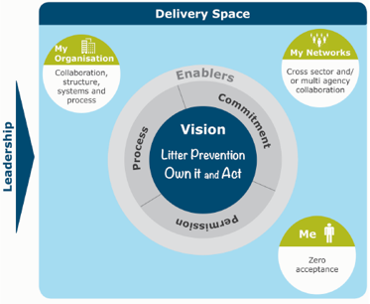

Who needs to ‘own it and act’?

In thinking about this framework, the first question is: who needs to own litter prevention? The EPA came up with three groups:

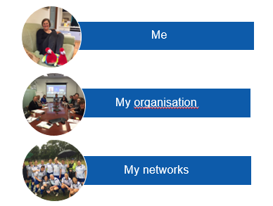

So far, litter prevention programs in NSW have been focussed on the individual – the ‘me’. And we are changing behaviour. But organisations and networks are also necessary to institutionalise litter prevention. The work that councils, land managers, businesses, community groups and industry sectors do is a different but absolutely necessary part of the litter prevention framework.

What are the enabling factors to help us all ‘own it and act’?

Leadership

We need a clear vision and an ambitious target. Leadership is the critical enabler that allows all other enablers to operate.

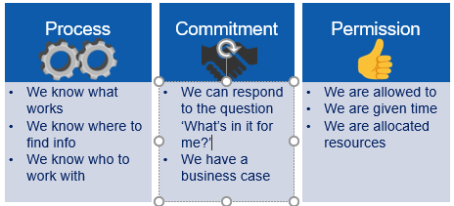

Process

This is about knowing what to do. Organisations, networks and individuals all need to know the best things they can do to influence litter reduction, and they should have the confidence to take action.

Commitment

This focuses on how to gain commitment from an organisation or network to take action. Commitment will come once a credible business case is made that answers the bottom line needs of the organisation or network. It might be budget, it might be reputation, it might be community complaints.

Permission

Each of us as individuals, or within an organisation or network, needs permission to take action. This can come through including litter prevention in a project plan, in a position description or in a budget.

1. Figures calculated from National Litter Index Annual Report 2017–18, Keep Australia Beautiful, unpublished.
2. [Clean Up Australia Cigarette Butts Fact Sheet](http://www.cleanup.org.au/files/clean_up_australia_cigarette_butts_factsheet.pdf)
3. The priority of beverage containers has been reduced to ‘medium’ due to the implementation of Return and Earn, which is targeting this category of litter in NSW.
4. Beverage Industry Environment Council, *Littering Behaviour 7: National Benchmark*, 2004, p 48